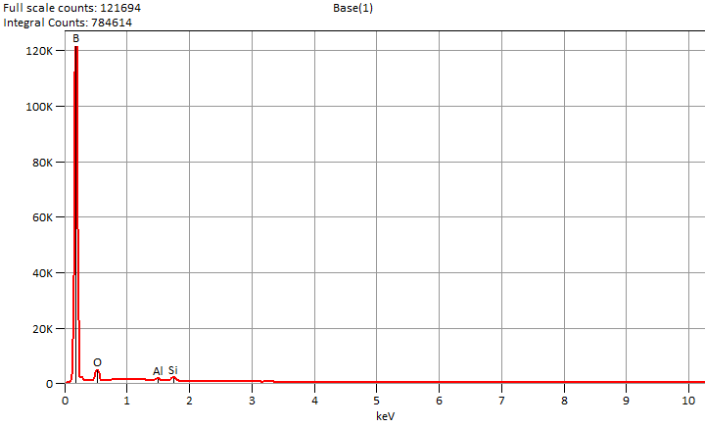

Live Time: 30.0 sec.

Wed Nov 27 14:14:10 2024

Filter Fit Chi Squared:586.751

Errors: +/- 1 Sigma

Correction Method: Proza (Phi-Rho-Z)

Acc.Voltage: 10.0 kV Take Off Angle: 45.8 deg.

Detector: UltraDry

WDS Results Unavailable for: Base(1)

|  |
| --- |
|  |

Quantitative Results for: Base(1)

|  |  |  |  |  |  |  |
| --- | --- | --- | --- | --- | --- | --- |
| ***Element***  ***Line*** | ***Int.***  ***Cps/nA*** | ***Int.***  ***Error*** | ***Weight %*** | ***Weight %***  ***Error*** | ***Atom %*** | ***Atom %***  ***Error*** |
| ***B K*** | 19024.3 | ± 165.8 | 89.4 | ± 0.8 | 93.4 | ± 0.8 |
| ***O K*** | 850.50 | ± 10.25 | 7.7 | ± 0.1 | 5.4 | ± 0.1 |
| ***Na K*** | 17.38 | ± 5.63 | 0.1 | ± 0.0 | 0.0 | ± 0.0 |
| ***Mg K*** | 28.33 | ± 6.00 | 0.1 | ± 0.0 | 0.0 | ± 0.0 |
| ***Al K*** | 195.21 | ± 10.25 | 0.7 | ± 0.0 | 0.3 | ± 0.0 |
| ***Si K*** | 488.58 | ± 10.50 | 2.1 | ± 0.0 | 0.8 | ± 0.0 |
| ***Total*** |  |  | 100.0 |  | 100.0 |  |

ROI Results for: Base(1)

|  |  |  |
| --- | --- | --- |
| ***Operation*** | ***Gross Counts*** | ***Net Counts*** |